ENCRYPTION AND DECRYPTION ALGORITHM BASED ON NEURAL NETWORK

S.NO | TITLE | PAGE NO
1 | 1.INTRODUCTION | 1
2 | 2.LITERATURE SURVEY | 3
3 | 3.SYSTEM ANALYSIS | 6
4 | 3.1 EXISTING SYSTEM | 7
5 | 3.2 PROPOSED SYSTEM | 7
6 | 3.3 SDLC MODEL | 9
7 | 3.4 FEASIBILITY REPORT | 11
8 | 3.4.1 TECHNICAL FEASIBILITY | 11
10 | 3.4.2 OPERATIONAL FEASIBILITY | 12
11 | 3.4.3 ECONIMICAL FEASIBILITY | 12
12 | 3.5 SYSTEM REQUIREMENTS | 13
13 | 3.6 SYSTEM SECURITY | 14
14 | 3.7 DATA FLOW DIAGRAM | 17
15 | 3.8 UML DIAGRAMS | 18
16 | 3.8.1 USE CASE DIAGRAM | 19
17 | 3.8.2 CLASS DIAGRAM | 22
18 | 3.8.3 SEQUENCE DIAGRAM | 24
19 | 3.8.4 ACTIVITY DIAGRAM | 25
20 | 3.9 INPUT DESIGN AND OUTPUT DESIGN | 26
21 | 4. IMPLEMENTATION | 28
22 | 4.1 MODULES | 30
23 | 4.2 SOFTWARE ENVIRONMENT | 31

S.NO | TITLE | PAGE NO
24 | 4.2.1 PYTHON | 31
25 | 4.2.2 HISTORY OF PYTHON | 32
26 | 4.3 SAMPLE CODE | 36
27 | 4.4. ALGORITHMS | 42
28 | 4.4.1 SUPPORT VECTOR MACHINE | 42
29 | 4.4.2 K-MEANS ALGORITHM | 43
30 | 4.4.3 ARTIFICIAL NEURAL NETWORK | 43
31 | 4.4.4 RANDOM FOREST TREE ALGORITHM | 44
32 | 4.4.5 LOGISTIC REGRESSION | 45
33 | 5.SYSTEM TESTING AND SCREEN SHOTS | 51
34 | 5.1 SYSTEM TESTING | 51
35 | 5.1.1 UNIT TESTING | 52
36 | 5.1.2 WHITE BOX TESTING | 52
37 | 5.1.3 BASIC PATH TESTING | 52
38 | 5.1.4 CONDITIONAL TESTING | 52
39 | 5.1.5 DATA FLOW TESTING | 53
40 | 5.1.6 LOOP TESTING | 53
41 | 5.1.7 TEST CASES | 53
42 | 5.2 OUTPUT SCREENSHOTS | 54
43 | 6. .CONCLUSION & FUTURE SCOPE | 58
44 | 7. REFERENCES & BIBLIOGRAPHY | 59

LIST OFFIGURES

FIGURENO | FIGURENAME | PAGE  NO
3.1 | SOFTWARE DEVELOPMENT LIFE CYCLE | 9
3.2 | USE CASE DIAGRAM | 21
3.3 | CLASS DIAGRAM | 23
3.4 | SEQUENCE DIAGRAM | 24
3.5 | ACTIVITY DIAGRAM | 25
5.1 | STRATERGIC APPROACH FOR TESTING | 51
5.2 | HOME SCREEN | 54
5.3 | KEY GENERATION | 55
5.4 | NEURAL NETWORK LOSS GRAPH | 56

LIST OF TABLES

Table no | Table name | Page no
5.1 | Test cases | 53

ABSTRACT

ABSTRACT

In order to prevent a cipher's plain text from being decoded without the corresponding key, cryptography is used. In network communication, security is a top priority. Encryption and decryption are the two main components of cryptography, which makes it possible to transfer private and secret information through an insecure network. Data must be hidden from unauthenticated users so that they cannot misuse it.

This is the fundamental principle of cryptography. It is nearly impossible to break the algorithm or the key using brute force if you use good cryptography. Good cryptography relies on extremely long keys and encryption algorithms that are resistant to other forms of attack Good cryptography's next step is represented by the neural net application. When it comes to cryptography, neural networks can be a useful tool. This paper discusses using neural networks for this purpose. Using neural networks to encrypt and decrypt, the neural network will be trained with keys and plain text in this study.
An experimental demonstration is also included in this project.

INTRODUCTION

1. INTRODUCTION

Cryptography is derived from the Greek word kryptos which means hidden or secret. It is a technique for safe communication in the presence of unsecure third party. It is a science and practice of hiding information and it is a combination of both mathematics and computer science branch. It involves both encryption and decryption of data. And it enables to send the data securely over the insecure network. Encryption is applying key on plain text to convert it into cipher text and decryption is the reverse process of encryption. Cryptography model is of basically two types one is symmetric model and asymmetric model.

CRYPTOGRAPHY
It is a science of hiding the important data while it travel’s in the unsecure network and it involves encryption to convert plain text into cipher text and decryption to convert the cipher text into the plain text.

Public Key Cryptography: It is a cryptography system where asymmetric cryptography model is used [2]. In this for encryption of plain text public key is used and public key is known by all the users in the network that is why it is called as shared key [1]. Decryption of cipher text in public key cryptography is done using private key only which means if receiver is having the respective private key then only the receiver can decrypt the message [3, 4]. Private Key is a secret key which is only known to the respective users and is hidden from others in the network.

Private Key Cryptography: It is a cryptography system where symmetric cryptography model is used. In this for encryption of plain text secret key is used which is private key and for decryption of cipher text also here same secret key is used [5]. As here in both the cases of encryption and decryption similar key is used so it is called shared secret key. Shared key used here is unique key for a session and is only disclosed to the sender and the receiver [6, 7].

LITERATURE SURVEY

2. LITERATURE SURVEY

There are many aspects to security and many applications, ranging from secure commerce and payments to private communications and protecting passwords. One essential aspect for secure communications is that of cryptography. Cryptography is the science of writing in secret code and is an ancient art; the first documented use of cryptography in writing dates back to circa 1900 B.C. when an Egyptian scribe used .non-standard hieroglyphs in an inscription. Some experts argue that cryptography appeared spontaneously sometime after writing was invented, with applications ranging from diplomatic missives to war-time battle plans. It is no surprise, then, that new forms of cryptography came soon after the widespread development of computer communications. In data and telecommunications, cryptography is necessary when communicating over any untrusted medium, which includes just about any network, particularly the Internet. Cryptography, then, not only protects data from theft or alteration, but can also be used for user authentication. There are, in general, three types of cryptographic schemes typically used to accomplish these goals: secret key (or symmetric) cryptography, public-key (or asymmetric) cryptography, and hash functions, each of which is described below. In all cases, the initial unencrypted data is referred to as plaintext. It is encrypted into cipher text, which will in turn (usually) be decrypted into usable plaintext.

Types of Cryptographic Algorithms :

There are several ways of classifying cryptographic algorithms. Here they will be categorized based on the number of keys that are employed for encryption and decryption. The three types of algorithms are:

Secret Key Cryptography –

With secret key cryptography, a single key is used for both encryption and decryption. As shown in the figure, the sender uses the key (or some set of rules) to encrypt the plaintext and sends the cipher text to the receiver. The receiver applies the same key (or rule set) to decrypt the message and recover the plaintext. Because a single key is used for both functions, secret key cryptography is also called symmetric encryption.

Public Key Encryption –

Public-key cryptography has been said to be the most significant new development in cryptography in the last 300-400 years. Modern PKC was first described publicly by Stanford University professor Martin Hellman and graduate student Whitfield in 1976. Their paper described a two-key crypto system in which two parties could engage in a secure communication over a non-secure communications channel without having to share a secret key. In PKC, one of the keys is designated the public key and may be advertised as widely as the owner wants. The other key is designated the private key and is never revealed to another party. It is straight forward to send messages under this scheme.

Hash Functions –

Hash functions, also called message digests and one-way encryption, are algorithms that, in some sense, use no key. Instead, a fixed-length hash value is computed based upon the plaintext that makes it impossible for either the contents or length of the plaintext to be recovered. Hash algorithms are typically used to provide a digital fingerprint of a file's contents, often used to ensure that the file has not been altered by an intruder or virus. Hash functions are also commonly employed by many operating systems to encrypt passwords. Hash functions, then, provide a measure of the integrity of a file.

3. SYSTEM ANALYSIS & DESIGN

3. SYSTEM ANALYSIS & DESIGN

3. 1. Existing system
Cryptographic software is vulnerable to software based assaults (e.g., malware) since the associated cryptographic keys can be compromised in their entirety. To lessen the impact of repeated attacks on cryptographic software, we look into key-insulated symmetric key cryptography in this study. Our proof of-concept implementation in a Kernel-based Virtual Machine (KVM) environment shows that key insulated symmetric key cryptography is feasible.

3.2 Proposed System
The ultimate goal is to make it possible for a coded message to be deciphered without the use of a Key. Encryption uses two main techniques: symmetric and asymmetric. In symmetric encryption, The encryption and decryption keys are shared by both parties. P stands for plain text, while K stands for the secret key used by the sender to construct C stands for encrypted, or cipher text, Artificial intelligence, machine learning, and deep learning all benefit from neural networks' ability to mimic the human brain's functioning. Deep learning methods rely on neural networks, often known as artificial neural networks (ANNs) or simulated neural networks (SNNs). Because they replicate the way biological neurons communicate with one another, their name and structure are derived from the human brain as well .The aim of this research is to develop an effective method to predict heart disease, in particular Coronary Artery Disease or Coronary Heart Disease, as accurately as possible.
Required steps can be summarized as follows:
- Five datasets are combined to develop a larger and more reliable dataset.
2) Two selection techniques, Relief and LASSO, are utilised to extract the most
relevant features based On rank values in medical references. This also helps to
deal with over fitting and under fitting Problems of machine learning.

3) Additionally, various hybrid approaches, including Bagging and Boosting, are
implemented to improve the testing rate and reduce the execution time.
4) The performance of the different models is Evaluated based on the overall results
with All, Relief and LASSO selected features.

3.3 Software Development Life Cycle

There are various software development approaches defined and designed which are
used/ employed during development process of software, these approaches are also referred as “Software Development Process Models". Each process model follows a particular life cycle in order to ensure success in process of software development.
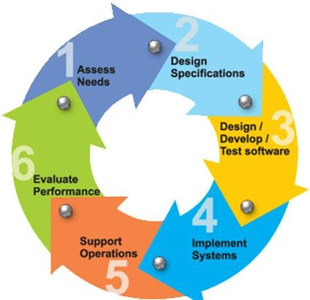
FIG : 3.1 SOFTWARE DEVELOPMENT LIFE CYCLE

Requirements

Business requirements are gathered in this phase. This phase is the main focus of the project managers and stakeholders. Meetings with manager, stakeholders and users are held in order to determine the requirements. Who is going to use the system? How will they use the system? What data should be input into the system? What data should be output by the system? These are general questions that get answered during a requirements gathering phase.

This produces a nice big list of functionality that the system should provide, which describes functions the system should perform, business logic that processes data, what data is stored and used by the system, and how the user interface should work. The overall result is the system as a whole and how it performs, no it is actually going to do it.

Design

The software system design is produced from the results of the requirements phase. Architects have the ball in their court during this phase and this is the phase in which their focus lies. This is where the details on how the system will work is produced.
Architecture, including hardware and software, communication, software design (UML is produced here) are all part of the deliverables of a design phase.

Implementation
Code is produced from the deliverables of the design phase during implementation, and this is the longest phase of the software development life cycle. For a developer, this is the main focus of the life cycle because this is where the code is produced. Implementation my overlap with both the design and testing phases.

Many tools exists (CASE tools) to actually automate the production of code using information gathered and produced during the design phase.

Testing
During testing, the implementation is tested against the requirements to make sure that the product is actually solving the needs addressed and gathered during the requirements phase. Unit tests and system/acceptance tests are done during this phase. Unit tests act on a specific component of the system, while system tests act on the system as a whole.

STUDY OF THE SYSTEM
In the flexibility of uses the interface has been developed a graphics concepts in mind, associated through a browser interface. The GUI’s at the top level has been categorized as follows
- Administrative User Interface Design
- The Operational and Generic User Interface Design
The administrative user interface concentrates on the information that is practically, part of the organizational activities and which needs Proper authentication for the data collection. The Interface helps the administration with all the transactional states like data insertion, data deletion, and data updating along with executive data search capability
3.4 FEASIBILITY REPORT

Preliminary investigation examine project feasibility, the likelihood the system will be useful to the organization. The main objective of the feasibility study is to test the Technical, Operational and Economical feasibility for adding new modules and debugging old running system. All system is feasible if they are unlimited resources and infinite time. There are aspects in the feasibility study portion of the preliminary investigation:
- Technical Feasibility
- Operational Feasibility
- Economical Feasibility

3.4.1TECHNICAL FEASIBILITY

The technical issue usually raised during the feasibility stage of the investigation includes the following:
- Does the necessary technology exist to do what is suggested?
- Do the proposed equipments have the technical capacity to hold the data required to use the new system?
- Will the proposed system provide adequate response to inquiries, regardless of the number or location of users?
- Can the system be upgraded if developed?
Are there-technical guarantees of accuracy, reliability, ease of access and data security?
Earlier no system existed to cater to the needs of ‘Secure Infrastructure Implementation System’. The current system developed is technically feasible. It is a web based user interface for audit workflow at NIC-CSD. Thus it provides an easy access to the users. The database’s purpose is to create, establish and maintain a work flow among various entities in order to facilitate all concerned users in their various capacities or roles. Permission to the users would be granted based on the roles specified.

Therefore, it provides the technical guarantee of accuracy, reliability and security. The software and hard requirements for the development of this project are not many and are already available in-house at NIC or are available as free as open source.
The work for the project is done with the current equipment and existing software technology. Necessary bandwidth exists for providing a fast feedback to the users irrespective of the number of users using the system.

Proposed projects are beneficial only if they can be turned out into information system. That will meet the organization’s operating requirements. Operational feasibility aspects of the project are to be taken as an important part of the project implementation. Some of the important issues raised are to test the operational feasibility of a project includes the following: -
- Is there sufficient support for the management from the users?
- Will the system be used and work properly if it is being developed and implemented?
- Will there be any resistance from the user that will undermine the possible application benefits?

3.4.2 OPERATIONAL FEASIBILITY

This system is targeted to be in accordance with the above-mentioned issues. Beforehand, the
management issues and user requirements have been taken into consideration. So there is no question of resistance from the users that can undermine the possible application benefits.
The well-planned design would ensure the optimal utilization of the computer resources and
would help in the improvement of performance status.

3.4.3 ECONOMICAL FEASIBILITY

A system can be developed technically and that will be used if installed must still be a good investment for the organization. In the economical feasibility, the development cost in creating the system is evaluated against the ultimate benefit derived from the new systems. Financial benefits must equal or exceed the costs.
The system is economically feasible. It does not require any addition hardware or software. Since the interface for this system is developed using the existing resources and technologies available at NIC, There is nominal expenditure and economical feasibility for certain.

3.5 SYSTEM REQUIREMENTS

Hardware Requirements

RAM : 4GB and Higher
Processor : Intel I3 and above
Hard Disk : 500GB Minimum

Software Requirements

- OS: Windows :or Linux
- Python IDE: python2.7.x and above
- Pycharm IDE Required
- Setup tools and pip to be installed for 3.6 and above
- Language: Python Scripting.

3.6 SYSTEM SECURITY

The protection of computer based resources that include hardware, software, data, procedures and people against unauthorized use or natural Disaster is known as System Security.
System Security can be divided into four related issues:

- Security
- Integrity
- Privacy
- Confidentiality

- SYSTEM SECURITY refers to the technical innovations and procedures applied to the hardware and operation systems to protect against deliberate or accidental damage from a defined threat.

- DATA SECURITY is the protection of data from loss, disclosure, modification and destruction.

- SYSTEM INTEGRITY refers to the power functioning of hardware and programs, appropriate physical security and safety against external threats such as eaves dropping and wire tapping.

- PRIVACY defines the rights of the user or organizations to determine what information they are willing to share with or accept from others and how the organization can be protected against unwelcome, unfair or excessive dissemination of information about it.

- CONFIDENTIALITY is a special status given to sensitive information in a database to minimize the possible in vision of privacy. It is an attribute of information that characterizes its need for protection.

3.6.1 FUNCTIONAL REQUIREMENTS
Outputs from computer systems are required primarily to communicate the results of processing to users. They are also used to provide a permanent copy of the results for later consultation. The various types of outputs in general are:
    - External Outputs, whose destination is outside the organization.
    - Internal Outputs whose destination is within organization and they are the
    - User’s main interface with the computer.
    - Operational outputs whose use is purely within the computer department.
    - Interface outputs which involve the user in communicating directly.
    - Understanding user’s preferences, expertise level and his business
    - Requirements through a friendly questionnaire.
    - Input data can be in four different forms –Relational DB, text files, xml files. For testing and demo you can choose data from any domain. User-B can provide business data as input.
To produce a cost-effective method of input.

    - To achieve the highest possible level of accuracy.
    - To ensure that the input is acceptable and understood by the user.

INPUT STAGES
The main input stages can be listed as below:
    - Data recording
    - Data transcription
    - Data conversion
Data verification
Data control
Data transmission
Data validation

INPUT TYPES
It is necessary to determine the various types of inputs. Inputs can be categorized as follows

3.6.2 NON-FUNCTIONAL REQUIREMENTS

Secure access of confidential data (user’s details). SSL can be used.

- 24X7availability.
- Better component design to get better performance at peak time
- Flexible service based architecture will be highly desirable for future extension.

PERFORMANCE REQUIREMENTS

Performance is measured in terms of the output provided by the application.
Requirement specification plays an important part in the analysis of a system. Only when the
requirement specifications are properly given, it is possible to design a system, which will fit into required environment. It rests largely in the part of the users of the existing system to give the requirement specifications because they are the people who finally use the system.

This is because the requirements have to be known during the initial stages so that the system can be designed according to those requirements. It is very difficult to change the system once it has been designed and on the other hand designing a system, which does not cater to the requirements of the user, is of no use.

The requirement specification for any system can be broadly stated as given below:
- The system should be able to interface with the existing system.
- The system should be accurate.
- The system should be better than the existing system.
- The existing system is completely dependent on the user to perform all the duties.

3.7 Data Flow Diagrams

A graphical tool used to describe and analyze the moment of data through a system manual or
automated including the process, stores of data, and delays in the system. Data Flow Diagrams are the central tool and the basis from which other components are developed. The transformation of data from input to output, through processes, may be described logically and independently of the physical components associated with the system. The DFD is also know as a data flow graph or a bubble chart.

DFDs are the model of the proposed system. They clearly should show the requirements on which the new system should be built. Later during design activity this is taken as the basis for drawing the system’s structure charts. The Basic Notation used to create a DFD’s are as follows:

Data flow: Data move in a specific direction from an origin to a destination.

Process: People, procedures, or devices that use or produce (Transform) Data. The physical component is not identified.

3. Source : External sources or destination of data, which may be People, programs,
organizations or other entity.

4. Data Store: Here data are stored or referenced by a process in the System.
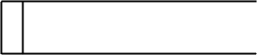

3.8 UML DIAGRAMS

UML SOFTWARE DESIGN
Software design sits at the technical kernel of the software engineering process and is applied regardless of the development paradigm and area of application. Design is the first step in the development phase for any engineered product or system. The designer’s goal is to produce a model or representation of an entity that will later be built. Beginning, once system requirement have been specified and analyzed, system design is the first of the three technical activities -design, code and test that is required to build and verify software.

The importance can be stated with a single word “Quality”. Design is the place where quality is fostered in software development. Design provides us with representations of software that can assess for quality.

Design is the only way that we can accurately translate a customer’s view into a finished software product or system. Software design serves as a foundation for all the software engineering steps that follow. Without a strong design we risk building an unstable system – one that will be difficult to test, one whose quality cannot be assessed until the last stage.

The purpose of the design phase is to plan a solution of the problem specified by the requirement document. This phase is the first step in moving from the problem domain to the solution domain. In other words, starting with what is needed, design takes us toward how to satisfy the needs. The design of a system is perhaps the most critical factor affection the quality of the software; it has a major impact on the later phase, particularly testing, maintenance.
The output of this phase is the design document. This document is similar to a blue print for the solution and is used later during implementation, testing and maintenance. The design activity is often divided into two separate phases System Design and Detailed Design.

System Design also called top-level design aims to identify the modules that should be in the system, the specifications of these modules, and how they interact with each other to produce the desired results. At the end of the system design all the major data structures, file formats, output formats, and the major modules in the system and their specifications are decided.

During, Detailed Design, the internal logic of each of the modules specified in system design is decided. During this phase, the details of the data of a module is usually specified in a high-level design. Description language, which is independent of the target.

3.8.1 USE CASE DIAGRAM

Use case diagrams model the functionality of a system using actors and use cases. Use cases are services or functions provided by the system to its users.

Basic Use Case Diagram Symbols and Notations:
System
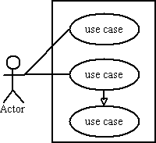
Draw your system's boundaries using a rectangle that contains use cases. Place actors outside the system's boundaries.

Use Case
Draw use cases using ovals. Label with ovals with verbs that represent the system's functions.

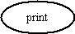

Actors
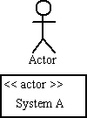

Relationships

Illustrate relationships between an actor and a use case with a simple line. For relationships among use cases, use arrows labeled either "uses" or "extends." A "uses" relationship indicates that one use case is needed by another in order to perform a task. An “extends" relationship indicates alternative options under a certain use case.

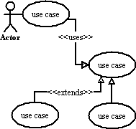

3.8.1USE CASE DIAGRAM
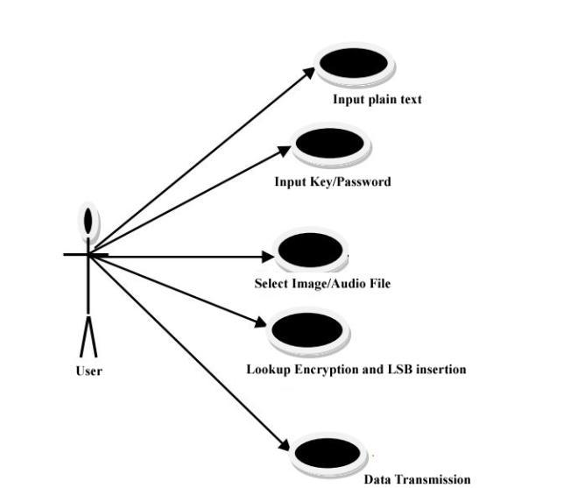

FIG3.2: Use case Diagram

3.8.2 CLASS DIAGRAM
Class diagrams are the backbone of almost every object-oriented method including UML. They describe the static structure of a system.
Basic Class Diagram Symbols and Notations.
Classes represent an abstraction of entities with common characteristics. Associations represent the relationships between classes.
Illustrate classes with rectangles divided into compartments. Place the name of the class in the first partition (centered, bolded, and capitalized), list the attributes in the second partition, and write.

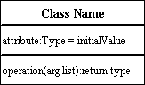

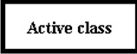
Active class: Active classes initiate and control the flow of activity, while passive classes store data and serve other classes. Illustrate active classes with a thicker border.

Associations : Associations represent static relationships between classes. Place association names above, on, or below the association line. Use a filled arrow to indicate the direction of the relationship. Place roles near the end of an association. Roles represent the way the two classes see each other.
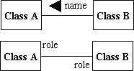
Note : It's uncommon to name both the association and the class roles.

Composition and Aggregation
Composition is a special type of aggregation that denotes a strong ownership between Class A, the whole, and Class B, its part. Illustrate composition with a filled diamond. Use a hollow diamond to represent a simple aggregation relationship, in which the "whole" class plays a more important role than the "part" class, but the two classes are not dependent on each other. The diamond end in both a composition and aggregation relationship points toward the "whole" class or the aggregate.
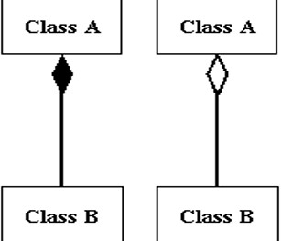

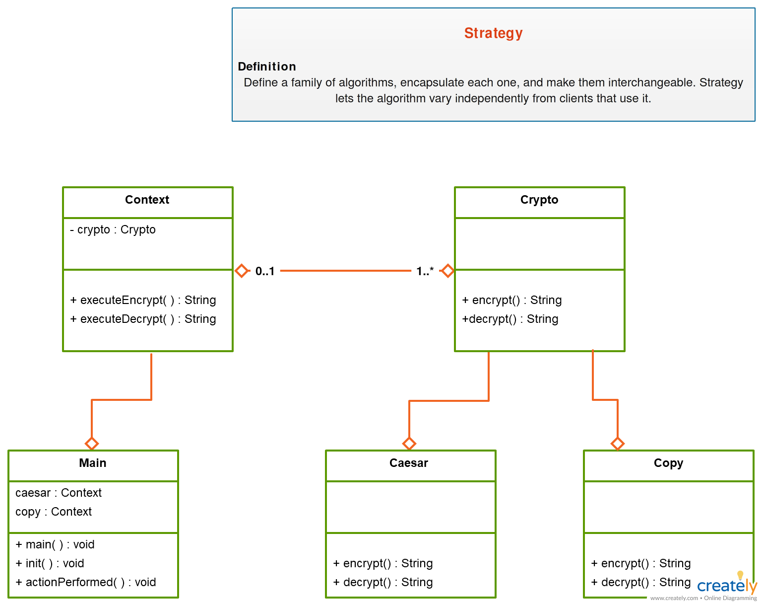
FIG3.3:Class Diagram
3.8.3 SEQUENCE DIAGRAM

A sequence diagram in Unified Modeling Language (UML) is a kind of interaction diagram that shows how processes operate with one another and in what order. It is a construct of a Message Sequence Chart. A sequence diagram shows, as parallel vertical lines ("lifelines"), different processes or objects that live simultaneously, and, as horizontal arrows, the messages exchanged between them, in the order in which they occur. This allows the specification of simple run time scenarios in a graphical manner.
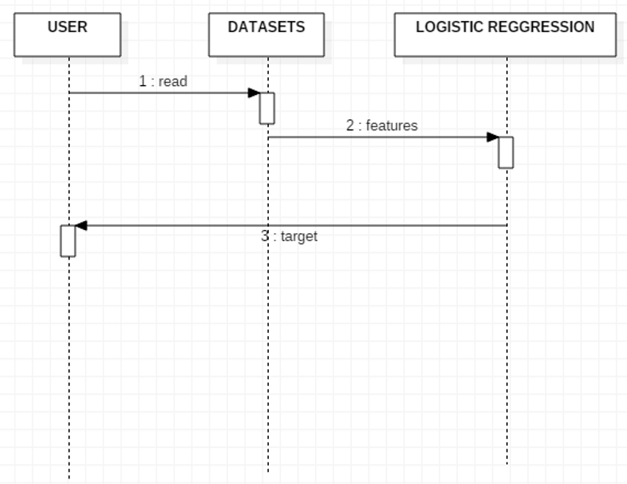
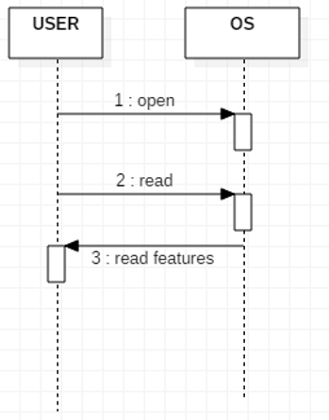

FIG 3.4. Sequence Diagram

3.8.4 ACTIVITY DIAGRAM

Activity diagrams are graphical representations of Work flows of stepwise activities and actions with support for choice, iteration and concurrency. In the Unified Modeling Language, activity diagrams can be used to describe the business and operational step-by-step workflows of components in a system. An activity diagram shows the overall flow of control.

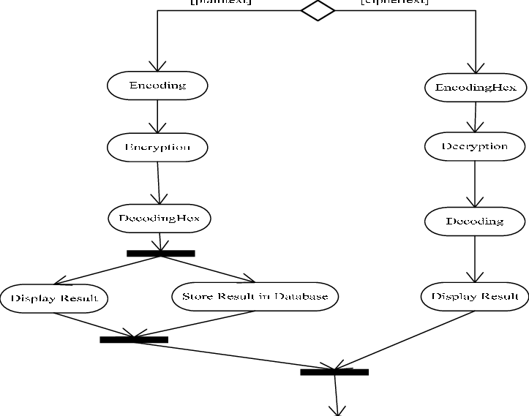

FIG3.5.:Activity Diagram
3.9 INPUT DESIGN AND OUTPUT DESIGN

3.9.1 INPUT DESIGN
The input design is the link between the information system and the user. It comprises the developing specification and procedures for data preparation and those steps are necessary to put transaction data in to a usable form for processing can be achieved by inspecting the computer to read data from a written or printed document or it can occur by having people keying the data directly into the system.

The design of input focuses on controlling the amount of input required, controlling the errors, avoiding delay, avoiding extra steps and keeping process simple. The input is designed in such a way so that it provides security and ease of use with retaining the privacy. Input Design considered the following things:
- What data should be given as input?
- How the data should be arranged or coded?
- The dialog to guide the operating person in providing input.
- Methods for preparing input validations and steps to follow when error occur.

OBJECTIVES
Input Design is the process of converting a user- oriented description of the input into a computer-based system. This design is important to avoid errors in the data input process and show the correct direction to the management forgetting correct information from the computerized system.

It is achieved by creating user-friendly screens for the data entry to handle large volume of data. The goal of designing input is to make data entry easier and to be free from errors. The data entry screen is designed in such a way that all the data manipulates can be performed. It also provides record viewing facilities.

When the data is entered it will check for its validity. Data can be entered with the help of screens. Appropriate messages are provided as when needed so that the user will not be in maize of instant. Thus the objective of input design is to create an input layout that is easy to follow.
3.9.2 OUTPUT DESIGN

A quality output is one, which meets the requirements of the end user and presents the information clearly. In any system results of processing are communicated to the users and to other system through outputs. In output design it is determined how the information is to be displaced for immediate need and also the hard copy output.
It is the most important and direct source information to the user. Efficient and intelligent
output design improves the system’s relationship to help user decision-making.

Designing computer output should proceed in an organized, well thought out manner; the right output must be developed while ensuring that each output element is designed so that people will find the system can use easily and effectively. When analysis design computer output, they should Identify the specific output that is needed to meet the requirements.

Select methods for presenting information.

Create document, report, or other formats that contain information produced by the system
The output form of an information system should accomplish one or more of the following objectives.
Convey information about past activities, current status or projections of the Future.
- Signal important events, opportunities, problems, or warnings.
- Trigger an action.
- Confirm an action.

Input Design
In this system admin can register vm’s information info Provider.
After that cloud Provider will accept the resource request/reject.
User registration.

Output design
In this place user can login after that they will migrate vm’s from one (A) host to
another host (B).
He will measured own time and migration time.

4. IMPLEMENTATION
4. IMPLEMENTATION
Introduction to Decision Tree Algorithm

Decision Tree algorithm belongs to the family of supervised learning algorithms. Unlike other
supervised learning algorithms, decision tree algorithm can be used for solving regression and
classification problems too.

The general motive of using Decision Tree is to create training model which can use to predict class or value of target variables by learning decision rules inferred from prior data (training data).

The understanding level of Decision Trees algorithm miss so easy compared with other classification algorithms. The decision tree algorithm tries to solve the problem, by using tree representation. Each internal node of the tree corresponds to an attribute, and each leaf node corresponds to a class label.

Decision Tree Algorithm Pseudo code

Place the best attribute of the data set at the root of the tree.
Split the training set into subsets. Subsets should be made in such a way that each subset contains data with the same value for an attribute.
Repeat step 1 and step 2 on each subset until you find leaf nodes in all the branches of the tree.
To follow the concept of white box testing we have tested each form .we have created independently to verify that Data flow is correct, All conditions are exercised to check their validity, All loops are executed on their boundaries.

4.1. MODULES

DATA SET
This paper utilizes the data set provided by revolution analytics for the detection of the cardio vascular dataset from Kaggle. Dataset has 51149 legal transactions and 3312 fraudulent transactions. The dataset is divided as 60%, 20% and, 20% in the Train, Valid and Test set, respectively.

DATA PREPROCESSING

For efficient implementation of the classification algorithm, data preprocessing is performed before feature selection. Under-sampling is performed to make the dataset balanced to avoid the biasing of the classification algorithm towards the majority class. Feature Selection is implemented on a balanced dataset.

FEATURE SELECTION

Feature selection methods are used to remove unnecessary, irrelevant, and redundant attributes from a dataset that do not contribute to the accuracy of a predictive model or which might reduce the accuracy of the model. In this paper seven feature selection techniques namely Select-K-best, Feature Importance, Extra tress classifier, Person’s correlation, Mutual Information, Step forward selection and Recursive feature elimination are used.

FEATURE IMPORTANCE

Feature importance is a class of techniques for assigning scores to input features to a predictive model that indicates the relative importance of each feature at the time of making a prediction. It reduces the number of input features. In this paper, feature importance is implemented using an extra tree classifier from the decision tree.

Extra Trees is similar to Random Forest, it builds multiple trees and splits nodes using random subsets of features, but unlike Random Forest, Extra Tree samples without replacement and nodes are split on random.

4.2. SOFTWARE ENVIRONMENT

USED LANGUAGES
In the implementation of proposed system, we used python as programming language. Python is beginner’s language, which provides various applications. In recent years, python had set the new trend because it is easy to use, interpreted, object-oriented, high-level, scripting language.

Python is one of the best languages for the implementing machine learning. It provides rich packages and libraries that used in machine learning.

4.2.1What is Python

Below are some facts about Python.
Python is currently the most widely used multi-purpose, high-level programming language.
Python allows programming in Object-Oriented and Procedural paradigms. Python programs generally are smaller than other programming languages like Java.
Programmers have to type relatively less and indentation requirement of the language, makes them readable all the time.

Python language is being used by almost all tech-giant companies like Google, Amazon, Facebook, Instagram, Dropbox, Uber… etc.

The biggest strength of Python is huge collection of standard library which can be used for the following–

Machine Learning
- GUI Applications (like Kivy, Tkinter, PyQt etc.)
- Web frame works like Django (used by YouTube, Instagram, Dropbox)
- Image processing (like Opencv, Pillow)
- Web scraping (like Scrapy, Beautiful Soup, Selenium)
- Test frame works
- Multimedia

4.2.2 History of Python

Python was developed by Guidovan Rossumin the late eighties and early nineties at the National Research Institute for Mathematics and Computer Science in the Netherlands.

Python is derived from many other languages, including ABC, Modula-3, C, C++, Algo68, SmallTalk, and Unix shell and other scripting languages.

Python is copy righted. Like Perl, Python source code is now available under the GNU General Public License (GPL).

Python is now maintained by a core development team at the institute, although Guidovan Rossum still holds a vital role in directing its progress.

Python Features
Python's features include−

- Easy-to-learn−Python has few keywords, simple structure, and a clearly defined syntax. This allows the
- Student to pick up the language quickly.
- Easy-to-read−Python code is more clearly defined and visible to the eyes.
- Easy-to-maintain−Python's source code is fairly easy-to-maintain.

A broad standard library − Python's bulk of the library is very portable and cross-platform compatible on UNIX, Windows, and Macintosh.

Interactive Mode− Python has support for an interactive mode which allows interactive testing and debugging of snippets of code.

Portable− Python can run on a wide variety of hardware platforms and has the same interface on all platforms.

Extendable−You can add low-level modules to the Python interpreter. These modules enable programmers to add to or customize their tools to be more efficient.
Databases− Python provides interfaces to all major commercial databases.

GUI Programming− Python supports GUI applications that can be created and ported to many system calls, libraries and windows systems, such as Windows MFC, Macintosh, and the X Window system of Unix.

Scalable− Python provides a better structure and support for large programs than shell scripting.

Advantages of Python Over Other Languages

1. Less Coding

Almost all of the tasks done in Python requires less coding when the same task is done in other languages. Python also has an awesome standard library support, so you don’t have to search for any third-party libraries to get your job done. This is the reason that many people suggest learning Python to beginners.

2. Affordable

Python is free therefore individuals, small companies or big organizations can leverage the free
available resources to build applications. Python is popular and widely used so it gives you better community support.

The 2019 Github annual survey showed us that Python has overtaken Java in the most popular
programming language category.

3. Python is for Everyone

Python code can run on any machine whether it is Linux, Mac or Windows. Programmers need to learn different languages for different jobs but with Python, you can professionally build web apps, perform data analysis and machine learning, automate things, do web scraping and also build games and powerful visualizations. It is an all-rounder programming language.

Install Python Step-by-Step in Windows and Mac:

Python a versatile programming language doesn’t come pre-installed on your computer devices. Python was first released in the year 1991 and until today it is a very popular high-level programming language. Its style philosophy emphasizes code readability with its notable use of great white space. The object-oriented approach and language construct provided by

Python enables programmers to write both clear and logical code for projects. This software does not come pre-packaged with Windows.

How to Install Python on Windows and Mac:

There have been several updates in the Python version over the years. The question is how to install Python? It might be confusing for the beginner who is willing to start learning Python but this tutorial will solve your query. The latest or the newest version of Python is version
.
Note: The python version 3.7.4 cannot be used on Windows XP or earlier devices.
Before you start with the installation process of Python. First, you need to know about your System Requirements. Based on your system type i.e. operating system and based processor, you must download the python version. My system type is a Windows 64-bitoperatingsystem.Sothestepsbelowaretoinstallpythonversion3.7.4onWindows7deviceortoinstallPython3. Download the Python Cheat sheet here. The steps on how to install Python on Windows10, 8 and 7 are divided into 4 parts to help understand better.

Packages and libraries used
Some of the python library and packages used in proposed system are as follows:

- Numpy

Numpy is a python library. Abbreviation of Numpy is numerical python library. Numpy package is used for multidimensional arrays and linear algebraic operations. 37 A. R B and S.K.K R Global Transitions Proceedings 2 (2021) 35–41
- Pandas

Pandas is a python library. Pandas is used for data analysis and data manipulation tool. It is used to read the dataset and load the dataset. It is fast, flexible when working with data.
- Keras

Keras is advanced stage of neural network application programming interface (API). It is able of run on top oftens or flow. Keras is mainly used while implementing deep learning algorithms such as CNN, RNN because its user friendly, modularity, and easy to extensibility.

Both CPU and GPU. In the experiment of finding the transaction we had used Keras along with backend running tensor flow. This Keras along with tenor flow backend makes excellent choice for training neural network architecture

- MySQL
MySQL is database which is used for storage purpose. In the experiment of fraud identification in card transaction we had used MySQL for storing the user details namely user name, password, email-id and phone number. While entering into application, user needs to register by providing the credential. These credentials are stored in database. Thereafter, user needs to login by giving username and password. The application will validate the login and registered information than user is moved to next window.

4.3. SAMPLE CODE
from tkinter import message box
from tkinter import *
from tkinter import simpledialog
import tkinter
from tkinter import filedialog
import matplotlib.pyplot as plt
from tkinter.filedialog import askopenfilename
import numpy as np
import os
from keras.models import Sequential
from keras.layers import Dense
from keras.layers import Dropout
from keras.layers import LSTM
from keras.utils import np_utils
from keras.layers import Bidirectional
from keras.models import model_from_json
import pickle
main = tkinter.Tk()
main.title("Encryption And Decryption Algorithm Based On Neural Network")
main.geometry("1300x1200")
global filename
global classifier
global char_to_int
global int_to_char
vocab_list = []
dataX = []
dataY = []
global n_vocab
global encrypt
def getID(chars,data):
index = 0
for i in range(len(chars)):
if chars[i] == data:
index = i;
break
return index
def generateKey():
global n_vocab
dataX.clear()
dataY.clear()
global char_to_int
global int_to_char
global filename
text.delete('1.0', END)
sentences = ''
with open('model/input.txt', "r") as file:
for line in file:
line = line.strip('\n')
line = line.strip()
line.lower()
sentences+=line
file.close()
sentences = sentences.strip()
vocab_list.clear()
for i in range(len(sentences)):
vocab_list.append(sentences[i])
raw_text = sentences
chars = sorted(list(set(raw_text)))
char_to_int = dict((c, i) for i, c in enumerate(chars))
int_to_char = dict((i, c) for i, c in enumerate(chars))
n_chars = len(raw_text)
n_vocab = len(chars)
text.insert(END,"Key Generation Task Completed\n")
for i in range(0, n_chars):
dataX.append(char_to_int.get(raw_text[i]))
dataY.append(getID(chars,raw_text[i]))
text.insert(END,"GenerateKey : "+str(char_to_int['w'])+str(char_to_int['p'])+str(char_to_int['l'])+str(char_to_int['e'])
+str(char_to_int['A'])+str(char_to_int['b'])+"\n")
def buildModel():
global classifier
text.delete('1.0', END)
n_patterns = len(dataX)
if os.path.exists('model/nn_model.json'):
with open('model/nn_model.json', "r") as json_file:
loaded_model_json = json_file.read()
classifier = model_from_json(loaded_model_json)
json_file.close()
classifier.load_weights("model/nn_model_weights.h5")
classifier._make_predict_function()
else:
seq_length = 1
X = np.reshape(dataX, (n_patterns, seq_length, 1))
X = X / float(n_vocab)
y = np_utils.to_categorical(dataY)
print(X.shape)
print(y.shape)
model = Sequential()
model.add(Bidirectional(LSTM(256, input_shape=(X.shape[1], X.shape[2]), return_sequences=True)))
model.add(Dropout(0.2))
model.add(Bidirectional(LSTM(256)))
model.add(Dropout(0.2))
model.add(Dense(y.shape[1], activation='softmax'))
model.compile(loss='categorical_crossentropy', optimizer='adam')
hist = model.fit(X, y, epochs=8000, batch_size=64)
model.save_weights('model/nn_model_weights.h5')
model_json = model.to_json()
with open("model/nn_model.json", "w") as json_file:
json_file.write(model_json)
json_file.close()
f = open('model/nn_history.pckl', 'wb')
pickle.dump(hist.history, f)
f.close()
f = open('model/nn_history.pckl', 'rb')
data = pickle.load(f)
f.close()
loss = data['loss']
lossValue = loss[7999]
loss = loss[0:100]
text.insert(END,"Neural Network Training Model Loss = "+str(lossValue)+"\n")
plt.figure(figsize=(10,6))
plt.grid(True)
plt.xlabel('Epoch/Iterations')
plt.ylabel('Loss')
plt.plot(loss, 'ro-', color = 'blue')
plt.legend(['Neural Network Loss'], loc='upper left')
plt.title('Neural Network Loss Graph')
plt.show()
def decimalToBinary(n):
return "{0:b}".format(int(n))
def encryption():
text.delete('1.0', END)
global encrypt
global classifier
encrypt = []
message = tf1.get();
binValue = ''
for i in range(len(message)):
data = char_to_int[message[i]]
temp = []
temp.append(data)
temp = np.asarray(temp)
x = np.reshape(temp, (1, temp.shape[0], 1))
x = x / float(n_vocab)
encrypted = classifier.predict(x, verbose=0)[0]
encrypt.append(np.argmax(encrypted))
binValue+=str(decimalToBinary(np.argmax(encrypted)))+" "
text.insert(END,"Original Message : "+message+'\n\n')
text.insert(END,"Encrypted Message Matrix : "+str(encrypt)+"\n\n")
text.insert(END,"Encrypted Binary Value : "+str(binValue.strip())+"\n\n")
def decryption():
text.delete('1.0', END)
global encrypt
global classifier
encrypt = np.asarray(encrypt)
output = ''
for i in range(len(encrypt)):
index = encrypt[i]
result = int_to_char[index]
output+=result
text.insert(END,"Decrypted Message : "+str(output)+"\n\n")
def close():
main.destroy()
font = ('times', 16, 'bold')
title = Label(main, text='Encryption And Decryption Algorithm Based On Neural Network')
title.config(bg='firebrick4', fg='dodger blue')
title.config(font=font)
title.config(height=3, width=120)
title.place(x=0,y=5)
font1 = ('times', 12, 'bold')
text=Text(main,height=17,width=150)
scroll=Scrollbar(text)
text.configure(yscrollcommand=scroll.set)
text.place(x=50,y=170)
text.config(font=font1)
font1 = ('times', 13, 'bold')
uploadButton = Button(main, text="Generate Key", command=generateKey, bg='#ffb3fe')
uploadButton.place(x=50,y=550)
uploadButton.config(font=font1)
lstmButton1 = Button(main, text="Build Neural Network Model", command=buildModel,
bg='#ffb3fe')
lstmButton1.place(x=350,y=550)
lstmButton1.config(font=font1)
l1 = Label(main, text='Enter Message')
l1.config(font=font1)
l1.place(x=50,y=100)
.tf1 = Entry(main,width=40)
tf1.config(font=font1)
tf1.place(x=230,y=100)
gruButton = Button(main, text="Neural Network Data Encryption", command=encryption,
bg='#ffb3fe')
gruButton.place(x=50,y=600)
gruButton.config(font=font1)
graphButton = Button(main, text="Neural Network Data Decryption", command=decryption, bg='#ffb3fe')
graphButton.place(x=350,y=600)
graphButton.config(font=font1)
predictButton = Button(main, text="Exit", command=close, bg='#ffb3fe')
predictButton.place(x=630,y=600)
predictButton.config(font=font1)
main.config(bg='LightSalmon3')
main.mainloop()

4.4 ALGORITHMS

4.4.1 Support Vector Machine:

Pseudo code:

Importing the necessary packages Example: import and as aspd

def SVM

Step 1: START

Step2: Reading the dataset.pd.read.csv (filename)#reads the data set file

Step3: Data cleaning and preprocessing of data

Resamplingthedataasnormalandfraudclassi.e.normal=0andfraud=1under

Under sampling of data is done • Data is scaled (if any null value then eliminated) and normalized.

•Data set is splitted into two set as train data and test data using split() on training data is used to split the data.
Step4: Training the data using the SVM algorithm

SVM classifier is called as classifier.predict () # which predicts whether transaction fraud or non fraud.
Step 5: Calculating the fraud transactions and valid transactions, then calculating the recall, precision and accuracy and stored in the respective locations
Step6: STOP

4.4.2 K-Nearest Neighbour

Pseudocode:
Step 1: START
Step2:Loadingofdatasetpd.read.csv (csvfile) #reads the csv file and loads
Step3: Cleaning and normalization of data
Normal=0
Fraud=1#resampling•Data is scaled and normalized

Train_test_split()#splitting of data set into train and test data

Step4: Train the model then fit the trained model

Trained the data using Knn classifier

KNeighborsClassifier()#knn classifier which does classification of transactions

Step5: Calculating the number of fraud, valid transactions and recall, precision and accuracy calculated.
Step 6: STOP

4.4.3 Artificial Neural Network(ANN):
Pseudocode:
The ANN algorithm has two parts: Training part and testing part. Training part: Def ANN:
Step 1: START
Step2: Loading and observing the dataset
pd.read.csv(.csv)#reads the data set
re sampling of data
StandardScaler()#scaling and normalization of data
Step3: Data pre-processing
Train_test_split()#Splitting of data
Step4: Training the model
Dense()#Adding data to activation function
Step5: Analyzing the model
•Prediction of fraud is made and this trained data is stored. It can used to test (training the model takes longer time so it is stored)

Step 6: STOP

Testing part:
Def ANN It is carried out similar way only difference is that the stored trained models used to test the data and classify it.

4.4.4 Random forest tree algorithm:

Random forests or random decision forests are an ensemble learning method for classification, regression and other tasks that operates by constructing a multitude of decision trees at training time. For classification tasks, the output of the random forest is the class selected by most trees.

For regression tasks, the mean or average prediction of the individual trees is returned. Random decision forests correct for decision trees' habit of over fitting to their training set. Random forests generally outperform decision trees, but their accuracy is lower than gradient boosted trees. However, data characteristics can affect their performance.

The first algorithm for random decision forests was created in 1995 by Tin Kam Ho[1] using the random subspace method, which, in Ho's formulation, is a way to implement the "stochastic discrimination" approach to classification proposed by Eugene Kleinberg.

An extension of the algorithm was developed by Leo Breiman and Adele Cutler, who registered "Random Forests" as a trademark in 2006 (as of 2019, owned by Minitab, Inc.).The extension combines Breiman's "bagging" idea and random selection of features, introduced first by Ho [1] and later independently by Amit and Geman[13] in order to construct a collection of decision trees with controlled variance Random forests are frequently used as "black box" models businesses, as they generate reasonable predictions across a wide range of data while requiring little configuration.

4.4.5 Logistic Regression Algorithm

Logistic regression is the appropriate regression analysis to conduct when the dependent variable is dichotomous (binary).

Like all regression analyses, the logistic regression is a predictive analysis. Logistic regression is used to describe data and to explain the relationship between one dependent binary variable and one or more nominal, ordinal, interval or ratio-level independent variables.
By using sigmoid function it calculates the probability and it compares that probability to the threshold probability and predicts the class of the observation.

Sequential Machine

A ``sequential machine'' is a device in which the output depends in some systematic way on variables other than the immediate inputs to the device. These ``other variables'' are called the state variables for the machine, and depend on the history or state of the machine. For example, in a counter, the state variables are the values stored in the flip flops.

The essence of a state table can be captured in a state diagram. A state diagram is a graph with labeled nodes and arcs; the nodes are the states, and the arcs are the possible transitions between states. In the project we have used the fact that the output of the sequential machine depend on the state of the machine as well as the input given to the sequential machine. Therefore we have used a Jordan network in which a few outputs are used as inputs, these outputs denote the states. A multilayered neural network is designed on this basis whish has a hard limiter in the output layer as a transfer function.

The network has 3 layers an input layer, a hidden layer and an output layer. The size of the input layer depends on the number of inputs and the number of outputs being used to denote the states. The learning algorithm used for this network is back propagation algorithm and the transfer function in the hidden layer is a sigmoid function. For implementation of sequential machine a serial adder and a sequential decoder is used.

The Serial Adder.

The serial adder accepts as input two serial strings of digits of arbitrary length, starting with the low order bits, and produces the sum of the two bit streams as its output. (The input bit streams could come from, say, two shift registers clocked simultaneously.) This device can be easily described as a state machine.
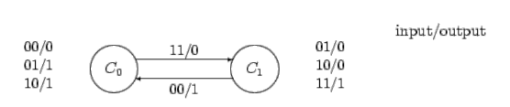

State diagram of Serial Adder

A Sequential Detector A state machine is required which outputs logic 1 whenever a particular sequence is detected in the input data stream, and which outputs a zero otherwise. The input is supplied serially, one bit at a time. The following is an example input sequence and output sequence:

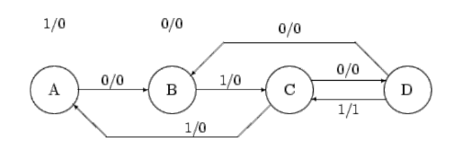

State diagram of Sequential Detector

The following is a state table corresponding to the state diagram. We can derive a state table from the state diagram as follows: Present state Inputs Next state Output
0 0 0 0 1 1 1 0 1 1 1 0 0 0 1 0 1 0 1 0 0 1 1 1
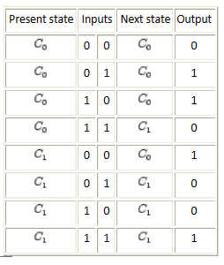
Table 2.1: State table of Sequential Detector Combinational Logic

A combinational circuit is one for which the output value is determined solely by the values of the inputs. A combinational circuit consists of input variables, output variables, logic gates and interconnections. The interconnected logic gates accept signals from the inputs and generate signals at the output. The n input variables come from the environment of the circuit, and the m output variables are available for use by the environment.

Each input and output variable exists physically as a binary signal that represents logic 1 or logic 0. For n input variables, there are 2n possible binary input combinations. For each binary combination of the input variables, there is one possible binary value on each output. Thus, a combinational circuit can be specified by a truth table that lists the output values for each combination of the input variables.

A combinational circuit can also be described by m Boolean function, one for each output variable. Each such function is expressed as function of the n input variables. In electronics, an adder is a digital circuit that performs addition of numbers. In modern computers adders reside in the arithmetic logic unit (ALU) where other operations are performed. Although adders can be constructed for many numerical representations, such as Binary-coded decimal or excess-3, the most common adders operate on binary numbers. In cases where twos complement or ones complement is being used to represent negative numbers, it is trivial to modify an adder into an adder-subtracter.

Many neural network designers are often curious about the capacity of a neural network. If they are able to know more about the capacity of neural networks, they would have an easier time deciding what neural network architecture to use as well as how many hidden neurons are needed for a neural network to perform a given function. Knowing the best architecture will save time with training, and allow for less expensive circuitry.

There are two neural network architectures considered: (1) Multilayer, multiple outputs feed-forward. (2) Multilayer, single output feed-forward. We examined the advantages of both these networks and proved/disproved the fact that a single bit per output neural network uses less overall neurons to perform the same function as a multilayered network. The problem studied includes a multiple bit digital adder and a multiple bit digital multiplier.

Cryptography
In the project cryptography has been achieved by using neural network in the following
manner:-
➢ Using a neural network based n-state sequential machine ➢ Using a chaotic neural
network

Cryptography Using Sequential Machine
For a sequential Machine, the output depends on the input as well as the state of the machine. Thus a sequential machine can be used in cryptography where the input data stream is the input to the sequential machine and the state determines the output input relationship. We can use the state of the sequential machine as the key and then use the data as an input to the sequential machine.

The relationship between different output and states can be any random but unique sequence providing security to the encryption. As a sequential machine can be implemented by using a neural network, therefore a neural network can be used to encrypt data and another to decrypt data. In this case the starting state of the sequential machine can act as a key. For this application the state diagram is drawn and the data is used to train the neural network as it provides the way the machine moves from one state to another.

Cryptography Using Chaotic Neural Network
A new chaotic neural network for digital signal encryption and decryption was studied in this project. According to a binary sequence generated from a chaotic system, the biases and weights of neurons are set. The chaotic neural network can be used to encrypt digital signal. The network's features are as follows: 1) High security 2) No distortion 3) Suitable for system integration.

The MATLAB simulation results are also included for demonstration. It indicates that the integration of the proposed system and MPEG2 for TV distribution, communication, and storage is practicable. Among the proposed encryption techniques, the basic ideas can be classified into three major types: a. Position permutation - The position permutation algorithms scramble the positions of original data. b. Value transformation - The value transformation algorithms transform the data value of the original signal. c. The combining form –
Finally, the combining form performs both operations. The encryption scheme belongs to the category of value transformation. Based on a binary sequence generated from the 1-D logistic map, the biases and weights of neurons are set in each iteration.

Chaos is statistically indistinguishable from randomness, and yet it is deterministic and not random at all. Chaotic system will produce the same results if given the same inputs, it is unpredictable in the sense that you cannot predict in what way the system's behavior will change for any change in the input to that system. A random system will produce different results when given the same inputs.

28 Chaotic neural network
Chaotic neural networks offer greatly increase memory capacity. Each memory is encoded by an Unstable Periodic Orbit (UPO) on the chaotic attractor. A chaotic attractor is a set of states in a system's state space with very special property that the set is an attracting set.

So the system starting with its initial condition in the appropriate basin, eventually ends up in the set. The most important, once the system is on the attractor nearby states diverge from each other exponentially fast, however small amounts of noise are amplified.


5. SOFTWARE TESTING & SCREEN SHOTS

5.1. SYSTEM TESTING.

The software engineering process can be viewed as a spiral. Initially system engineering defines the role of software and leads to software requirement analysis where the information domain, functions, behavior, performance, constraints and validation criteria for software are established.

Moving inward along the spiral, we come to design and finally to coding. To develop computers of we spiral in a long stream lines that decrease the level of abstraction on each turn.
A strategy for software testing may also be viewed in the context of the spiral. Unit testing begins at the vertex of the spiral and concentrates on each unit of the software as implemented in source code.

Testing progress by moving outward along the spiral to integration testing, where the focus is on the design and the construction of the software architecture. Talking another turn on outward on the spiral we encounter validation testing where requirements established as part of software requirements analysis are validated against the software that has been constructed. Finally we arrive at system testing.
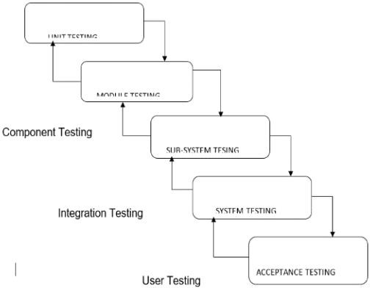
FIG: 5.1: STRATEGIC APPROACH FOR TESTING

5.1.1 UNIT TESTING

Unit testing focuses verification effort on the smallest unit of software design, the module. The unit testing we have is white box oriented and some modules the steps are conducted in parallel.

5.1.2 WHITE BOX TESTING

This type of testing ensures that
All independent paths have been exercised atleast once.
All logical decisions have been exercised on their true and false sides.
All loops are executed at their boundaries and within their operational bounds.
All internal data structures have been exercised to assure their validity.

5.1.3 BASIC PATH TESTING

Established technique of flow graph with Cyclomatic complexity was used to derive cases for all the functions. The main steps in deriving test cases were:
Use the design of the code and draw correspondent flow graph.

Determine the Cyclomatic complexity of resultant flow graph, using formula: V(G)=E-N+2or
V(G)=P+1or

V(G)=Number Of Regions
Where V(G) is Cyclomatic complexity, E is the number of edges,
N is the number of flow graph nodes, P is the number of predicate nodes.
Determine the basis of set of linearly independent paths.

5.1.4 CONDITIONAL TESTING
In this part of the testing each of the conditions were tested to both true and false aspects. And all the resulting paths were tested. So that each path that may be generate on particular condition is traced to uncover any possible errors.

5.1.5 DATA FLOW TESTING
This type of testing selects the path of the program according to the location of definition and use of variables. This kind of testing was used only when some local variable were declared. The definition-use chain method was used in this type of testing. These were particularly useful in nested statements

5.1.6 LOOT TEST
In this type of testing all the loops are tested to all the limits possible. The following exercise was adopted for all loops:
All the loops were tested at their limits, just above them and just below them.
All the loops were skipped atleast once.
For nested loops test the inner most loop first and then work outwards.
For concatenated loops the values of dependent loops were set with the help of Connected loop. Unstructured loops were resolved into nested loops or concatenated loops and tested as above.

5.1.7. TEST CASES

TCID | Condition Being Tested | Expected Result | Result
1 | Check if data set is taken as input | If taken process next step else throw error | passed
2 | Check for null values in the dataset | If null values drop the null  Records | Passed
3 | Check for future extraction and save the file in.pkl format | If file not saved throw the error | passed

Table:5.1 Test Cases

5.2. SCREEN SHOTS

5.2.1 Home screen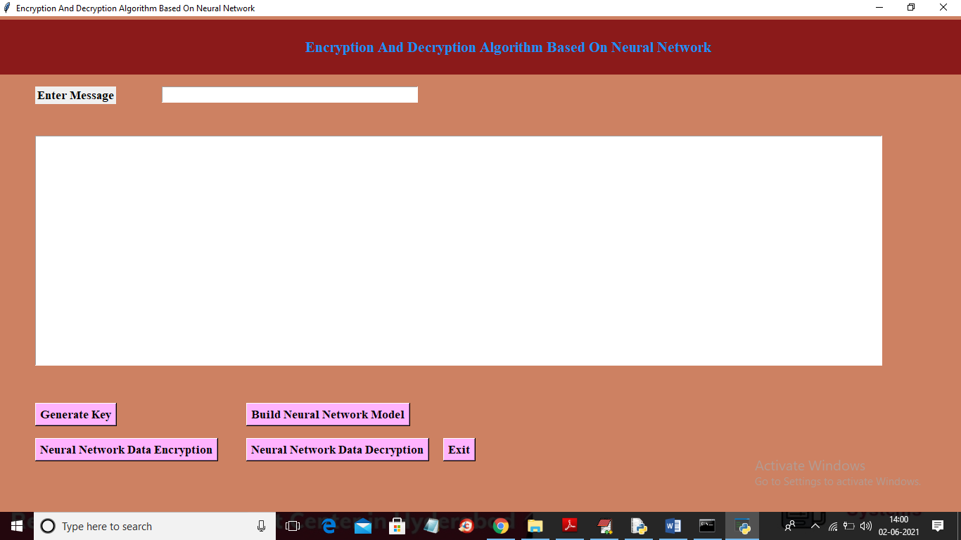

Fig: 5.2 Home screen

5.2.2 Key Generation

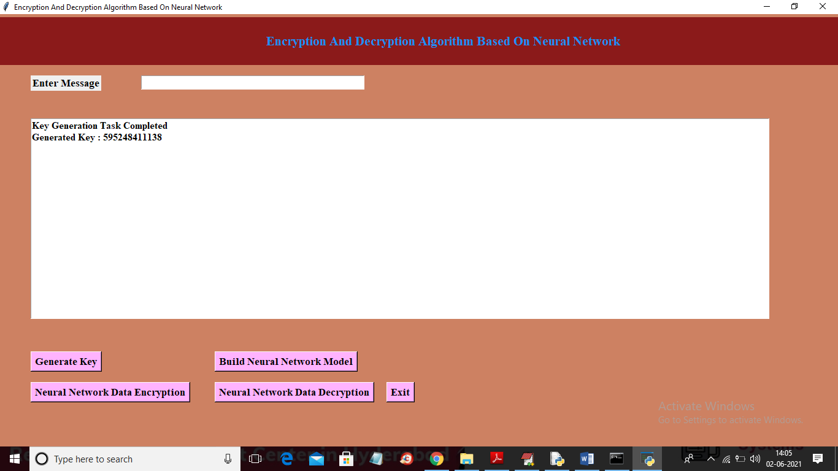

5.3. Key Generation

5.2.3 NEURAL NETWORK LOSS GRAPH
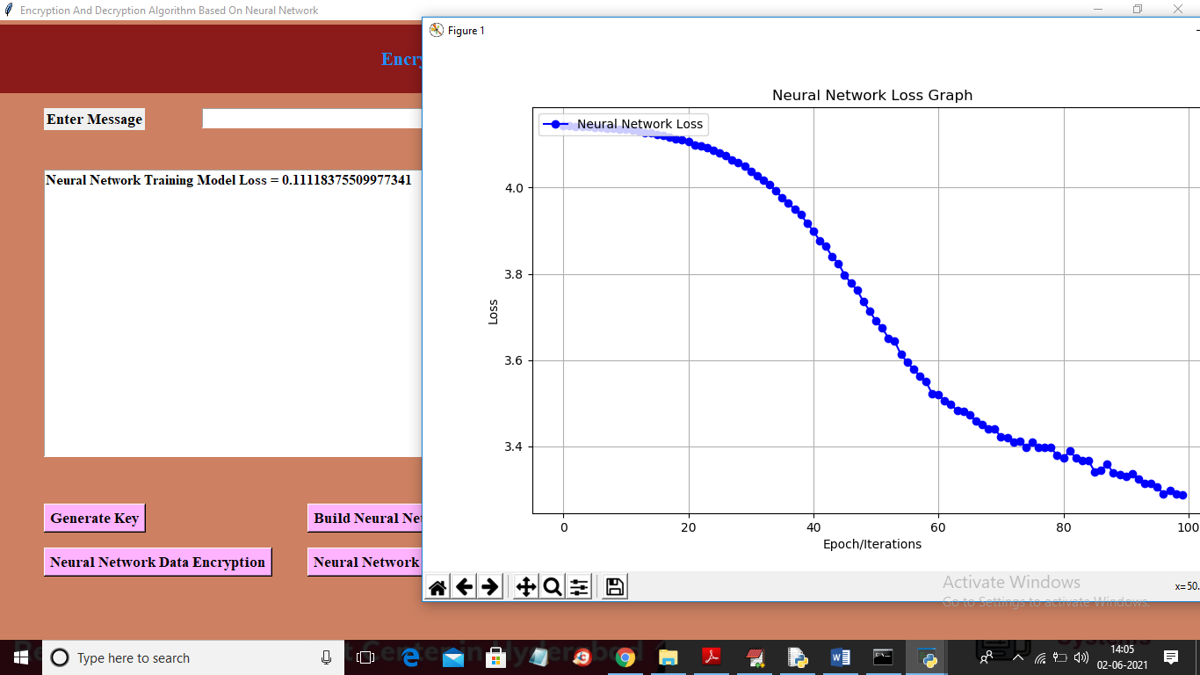

FIG: 5.4 NEURAL NETWORK LOSS GRAPH

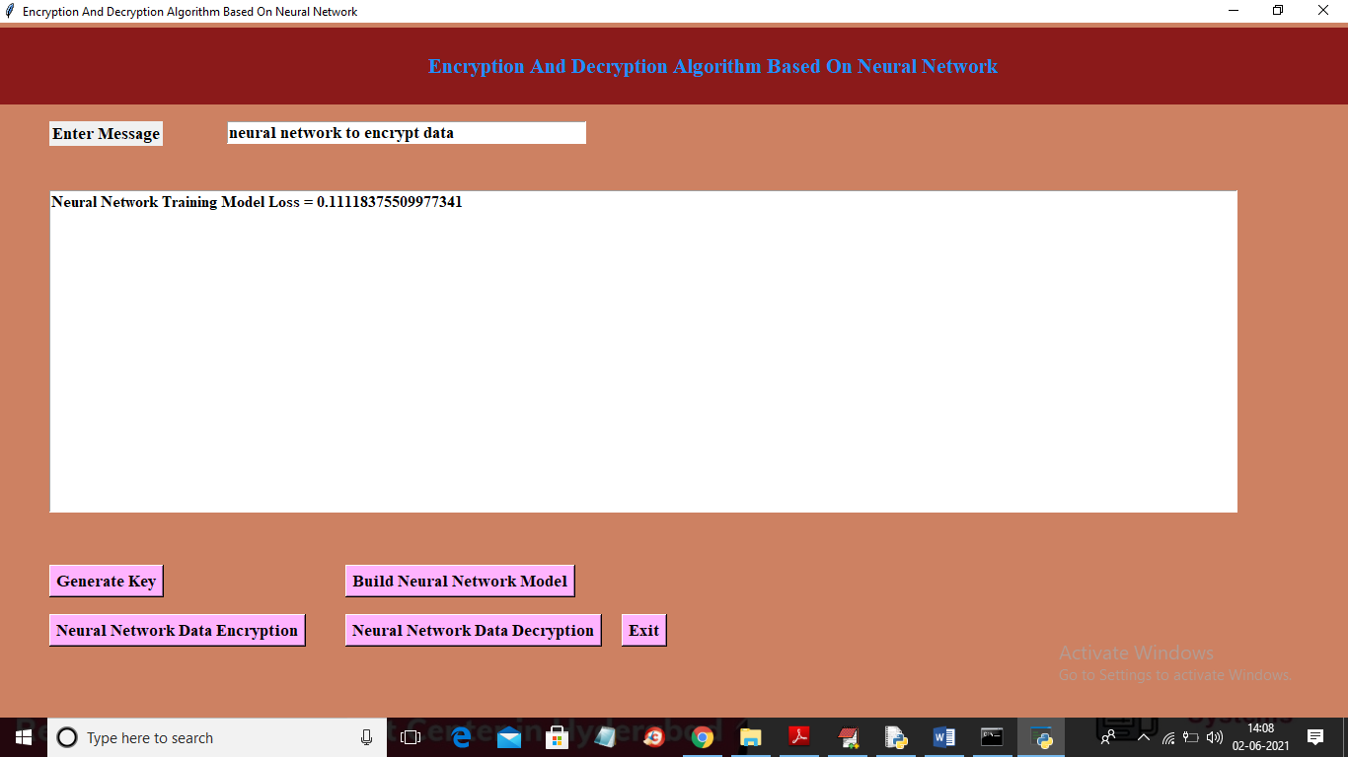

NEURAL ENCRYPTION OF DATA



NEURAL DECRYPTION OF DATA
6. Conclusion and Future scope

The concept of using neural networks in the field of cryptography is growing at a rapid pace. Various neuro-crypto algorithms proposed by researchers are available in literature. But most of them are limited to the key generation and cryptanalysis. In the research work auto associative memory network is utilized to encrypt the plain text into the form which is totally independent from the previous one. The algorithm is pretty simple to implement and has faster encryption and decryption speed. The algorithm is following the symmetric key system which makes it vulnerable to leakage of key. To overcome this, only trusted parties should be involved in communication or a trusted third party can be used as an authority to prevent the key leakage.

The overall discussion has shown that the performance of Different classifiers were good enough in comparison to Previous studies, however, there are indeed few limitations, Such as, the dependency on a specific Feature Selection Technique, for instance more reliance on Relief in this case To produce highly accurate results. Additionally, high level Of missing values in the dataset can have an adverse effect? We have demonstrated how to address the issue through the Proper methods and therefore other dataset when used with This model, must also take care of this issue if the missing Value is quite significant. Furthermore, though our training

REFERENCES
&
BIBILOGRAPHY

15. REFERENCES

[1] M. Hellman, "An overview of public key cryptography", IEEE Communications Magazine, 2002, 40(5): 42-49.

[2] Diffie W, Hellman M., "New Directions in Cryptography". IEEE Transactions on Information Theory. 1976, 22(6):644-654.

[3] L. P. Yee and L. C. D. Silva. Application of multilayer per- ceptron networks in public key cryptography. Proceedings ofIJCNN02,2 (Honolulu,HI,USA):1439–1443, May2002.

[4] Salomaa, Arto. Public-key cryptography. Springer Science & Business Media, 2013.

[5] Law, Laurie, et al. "An efficient protocol for authenticated key agreement."Designs, Codes and Cryptography 28.2 (2003): 119-134.

[6] McInnes, James L., and Benny Pinkas. "On the impossibility of private key cryptography with weakly random keys." Advances in CryptologyCRYPT0’90. Springer Berlin Heidelberg, 1991. 421-435.

[7] Dodis, Yevgeniy, et al. "Key-insulated symmetric key cryptography and mitigating attacks against cryptographic cloud software." Proceedings of the 7th ACM Symposium on Information, Computer and Communications Security. ACM, 2012.

[8] Jacob, Theju, and Wesley Snyder. "Learning rule for associative memory in recurrent neural networks." Neural Networks (IJCNN), 2015 International Joint Conference on. IEEE, 2015.

[9] Vallet, F. "The Hebb rule for learning linearly separable Boolean functions: learning and generalization." EPL (Europhysics Letters) 8.8 (1989): 747.

[10] Phadke, Akshay, and Aditi Mayekar. "New Steganographic Technique using Neural Network." International Journal of Computer Applications 82.7 (2013): 39-42.

[11] Nakano, Kaoru. "Associatron-a model of associative memory." Systems, Man and Cybernetics, IEEE Transactions on 3 (1972): 380-388.

[12] Amari, S-I. "Neural theory of association and concept formation." Biological cybernetics 26.3 (1977): 175-185.

[13] Wang, Guofeng, and Yinhu Cui. "On line tool wear monitoring based on auto associative neural network." Journal of Intelligent Manufacturing 24.6 (2013): 1085-1094.

[14] Widrow, Bernard, Juan Carlos Aragon, and Brian Mitchell Percival. "Cognitive memory and auto-associative neural network based search engine for computer and network located images and photographs." U.S. Patent No. 7,991,714. 2 Aug. 2011.

[15] Valentin, Dominique, Hervé Abdi, and Alice J. O’TOOLE. "Categorization and identification of human face images by neural networks: A review of the linear auto associative and principal component approaches." Journal of biological systems 2.03 (1994): 413- 429.

